# Rafting Site - Planning Document

*1.The image file you selected for the site logo.*

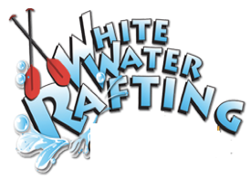

*2.Write out the four (4) color labels (listed below) with the color codes you selected*

*\*Primary Color: #1d4ed8 (Brighter Blue)*

*\*Secondary Color: #06b6d4 (Brighter Cyan)*

*\*Accent Color: #16a34a (Bright Green)*

*\*Accent2 Color: #e0f7fa (Light Aqua)*

1. *Write out the two (2) font labels (listed below) and the names of the fonts you selected*

*\** ***Heading Font****: Poppins*

*\** ***Text Font****: Roboto*

1. *Provide the URL link to your color palette that you designed in coolors.co  
   Here is an example URL link:*

*https://coolors.co/1d4ed8-06b6d4-16a34a-e0f7fa*